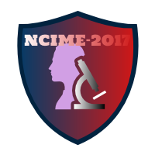

Author’s Guidelines

1) Firstly, Authors need to upload extended abstract of the paper in normal format. (Only word 2007) ([www.ncime.com](http://www.ncime.com)).

2) Selection of paper for peer review will be based on extended abstract, so Authors are advised to add important details of research work in extended abstract.

3) All selected research papers will be communicated by mail to corresponding Authors and list of selected papers will be displayed on conference website.

4) Secondly, after paper selection confirmation, Authors need to upload full length of paper (Only word 2007) on conference website as per given format.

5) Authors need to include following sections in paper: Title, Authors and Affiliation, Abstract, Introduction, Methods, Results, Discussion, Acknowledgments (optional), Literature Cited and Appendices (optional).

6) Final confirmation of paper selection will be communicated to corresponding Authors by mail and will be displayed on conference website.

7) Lastly, after getting final paper selection confirmation, Authors need to fill online registration form available on conference website. ([www.ncime.com](http://www.ncime.com)).

8) Name of the Journals for selected papers will be communicated.

9) Authors need to complete all Conference formalities and need to present paper in conference.